Pillar Church Planting Residency Syllabus

Purpose

The Pillar church-planting residency is designed to prepare Biblically qualified men to plant faithful reproducing churches in the National Capital Region. The residency aims to introduce God called men to a body of helpful resources and relationships that will serve them as they endeavor to plant faithful churches in DC and beyond. The residency is not to be considered exhaustive training for pastoral ministry but rather a residency for those already formally trained but lacking ministerial experience and specific training in the area of church planting. Candidates selected will either be formally trained for ministry at a trusted institution or will have exhibited a sufficient competency in that area before acceptance into the residency.

Overview

The Pillar Church Planting residency is a minimum of one-year residential program requiring full time attention generally beginning in August of each year and concluding in July. The residency combines practical “hands on” pastoral experiences, academic instruction, and pastoral mentorship.

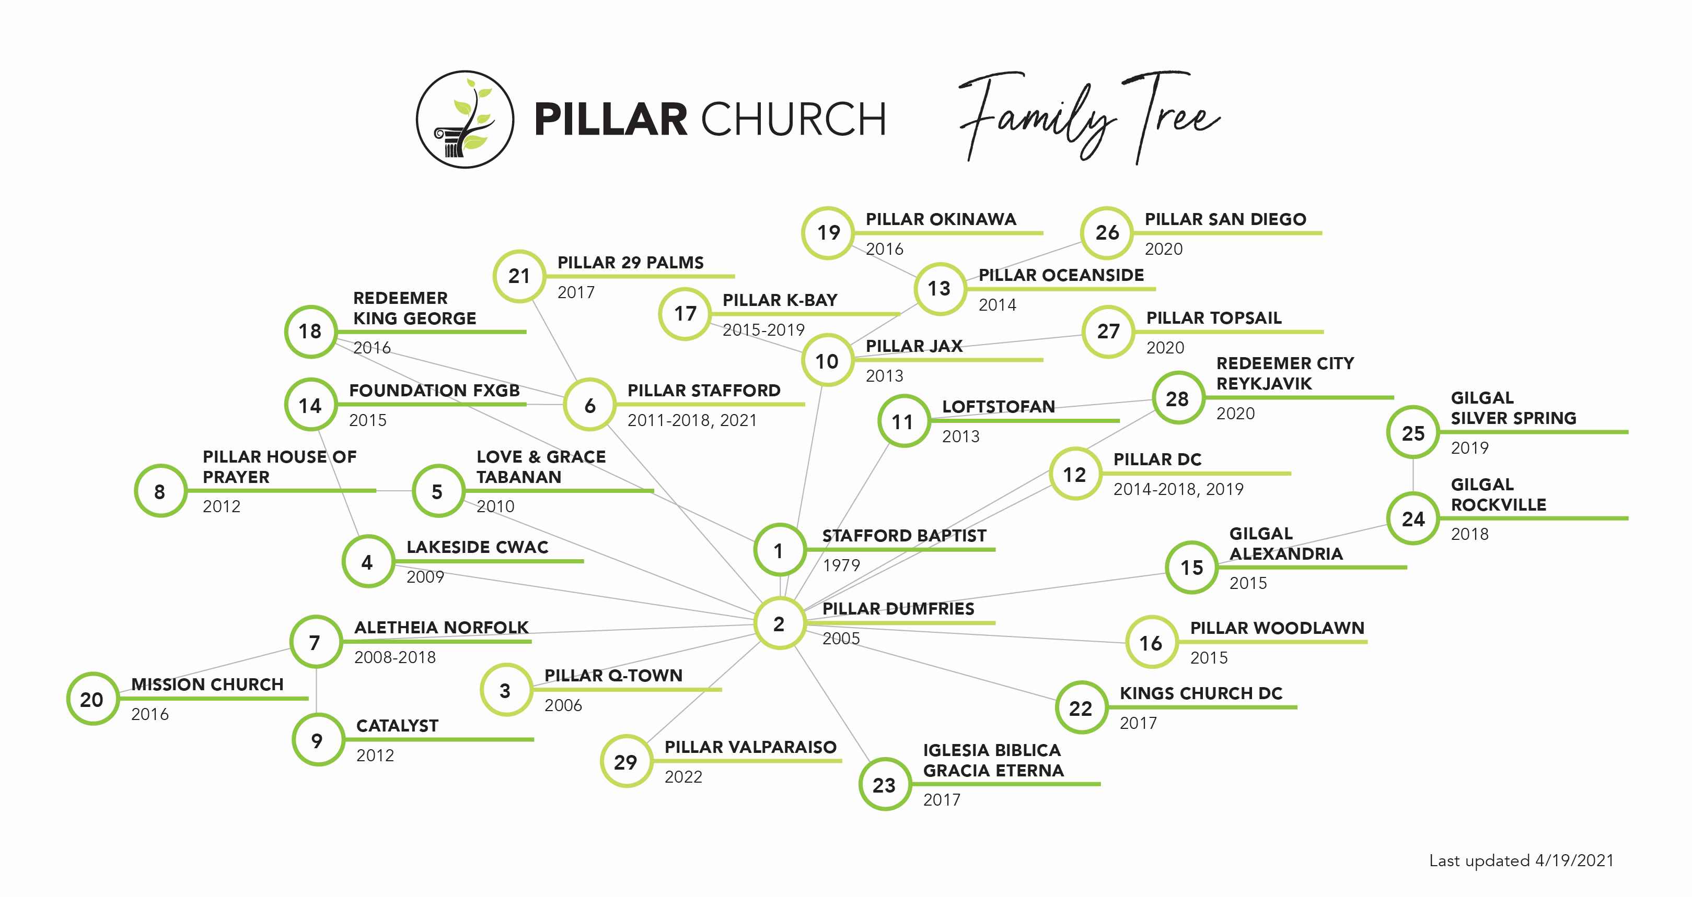

NAMB & SBCV Partnership

Pillar Church conducts this residency in partnership with the North American Mission Board, The New City Network and the Southern Baptist Conservatives of Virginia specifically for church planting in the National Capital Region. Accepted residents will be expected to plant Southern Baptist churches in the Greater DC area at the conclusion of their time in residence. These churches are expected to work toward reproduction early and to work in happy cooperation with both SBCV, NAMB and New City into the foreseeable future.

Acceptance Steps:

- Express interest in the residency through email to info@pillarchurchsbc.com
- Fill out the “Prospective Church Planter Questionnaire”
- Apply and receive acceptance to the NAMB Church Planting Apprenticeship, begin application process at www.namb.net (takes approximately 2 months)
- Confirm agreement with the BF&M 2000 and the NAMB Code of Conduct
- Confirm spousal approval (basically we want to talk to your wife to make sure she is on board)
- Confirm agreement with the Pillar Church Planter Commitments (Appendix B of the Thresholds book)

Some Expectations:

- Serve as a faithful member of Pillar Church of Dumfries throughout the residency.
- Attend a weekly resident meeting (2 Hours).
- Assemble a church planting team.
- Complete 36 weekly reading/media assignments.
- Complete the “Church Planting Thresholds”
- Prepare a comprehensive plan for the new church.
- Remain faithful, available and teachable throughout the process.
- Attend Elder and staff meetings.

Residency Stages

The residency begins on August 1st of each year and lasts a full 12 months. The residency has four parts, lasting approximately three months each. They are as follows:

Stage 1 - Assimilation

During the assimilation phase residents will:

- Become a member of Pillar Church of Dumfries (if they are not already)
- Attempt to begin a Bible study in Dumfries made up of individuals not currently connected with the pillar church Family.
- Work to form relationships with as many members and leaders in the church as possible.
- Recruit a Pastoral Partner
- Research potential ministry fields and make key decisions such as location, church name, timeline, team size and budget requirements.
- During the assimilation period residents will spend approximately 75% of their time on matters related to Pillar Dumfries and 25% of their time on matters related to the new church.

Stage 2 - Planning

During the planning phase residents will:

- Write a prospectus
- Produce a promotional film
- Create a website
- Set up giving options and bank accounts
- Create a wish list
- Complete a funding summary
- Schedule speaking engagements for the rest of the year
- Present vision to Pillar Dumfries
- During the planning phase residents will spend approximately 50% of their time on matters related to Pillar Dumfries and 50% of their time on matters related to the new church.

Stage 3 - Gathering

During the Gathering phase residents will:

- Speak in other churches
- Participate in partnership opportunities.
- Begin core team meetings
- Apply with State Conventions, Associations and networks for affiliation.
- Plan Preview Services and Informational meetings
- During the gathering phase residents will spend approximately 25% of their time on matters related to Pillar Dumfries and 75% of their time on matters related to the new church.

Stage 4 - Transitioning

During the Transition phase residents will:

- Write Theological Position Paper
- Complete ordination process
- Hold informational meetings and preview services.
- Continue Support Gathering
- Gain acceptance from partners
- Secure hosing on ministry field.
- During the planning phase residents will spend approximately 75% of their time on matters related to Pillar Dumfries and 25% of their time on matters related to the new church.

Compensation Information:
This is standard compensation information. Situations vary from resident to resident.
- NAMB Contribution: XX
- SBCV Contribution: XX
- Pillar Contribution: XX
- New City Contribution: XX

Annual Church Planters Retreat

Each year planters related to Pillar Churches are invited, with their families to participate in a church planters retreat. The retreat takes places annually in the spring beginning on Easter Tuesday and concluding on the Friday after Easter. The retreat is not required but strongly suggested.

Residency Books:

- Church Planting Thresholds - Clint Clifton
- Church Planting Primer – Clint Clifton
- Center Church - Tim Keller
- Good Christians. Good Husbands? – Doreen Moore
- Trellis and the Vine - Tony Payne and Colin Marshall
- The Christian Ministry - Charles Bridges
- The Gospel Blimp - Joseph Bayly
- Church Elders – Jeramie Rinne
- The Pastors Kid – Barnabas Piper
- Questioning Evangelism – Randy Newman
- When People are Big and God is Small – Ed Welch
- The Church Planting Wife – Christine Hoover
- Am I Called – Dave Harvey
- A Display of God’s Glory – Mark Dever

Residency Weekly Meetings:

Each week you will meet for two hours with a pastor or elder from the Pillar Church family to work on areas of preparation for church planting. Though the residency is a full 52 weeks your weekly assignments will only last through the spring. Please make sure you have completed the assigned reading and media assignments when you arrive at the meeting. Also, please note that the this list is likely to be updated and amended regularly, as a result you can always find the most current version of it on www.pillarplanting.com at the bottom of the homepage by clicking the button titled “Residency Syllabus”. There you will also find a button titled, “Residency Media” where you will find all of the media assignments listed in the right column, again, this folder is dynamic and will be updated on a regular basis.
Lesson # | Subject | Reading | Media
1 | Am I Called? | - Thresholds, Clifton (Chap 1) “Confirming Your Call”  - Am I Called, Harvey (Chap 4) “Are You Godly” | P001,
2 | Am I Healthy Enough? | - When People are Big, (chap 8 & 9) “Biblically Examine Your Felt Needs”, “Know Your Real needs”  - Interview with Ed Welch, Clifton (R007)  - Ministry and Character, Tim Keller (R012) | A006,
3 | How’s My Family? | - Am I Called, Harvey (Chap 5) “How’s Your Home”  - The Christian Ministry, Bridges (Ch IX) “The Defect of Family Religion” pp.165-173  - Good Christians, Good Husbands?, (Chap 1) “The Marriage of John Wesley” | P013,
4 | How Will My Family Be Affected? | - PLANT, Clifton (Ch. 9) – “Pastoral Health” (R029)  - Good Christians, Good Husbands?, (Chap 2-3) “The Marriage of George Whitefield”, “The Legacy of Jonathan Edwards”  - The Pastors Kid, Piper (Chap 1) | P008, P009,
5 | Pastoral Partners | - Thresholds, Clifton (Chap 2) “Enlist a Partner and a Mentor”  - The Pastors Kid, Piper (Chap 2,3) | P003,
6 | Practical Aspects of Plural Leadership | - Church Elders, (Chap 1-4) | P002,
7 | Painting the Big Picture | - Thresholds, Clifton (Chap 3) “Make a Comprehensive Plan”  - Study Sample Prospectus Folder on Resource Disk | P004,
8 | Stewarding Your Time | - 9 Tips to Manage Your Time in Ministry, Evans (R027)
9 | Presenting Your Plan
10 | Counting the Costs (Budgeting) | - Basic Budgeting, Owen (R002) | V008, R001, R020,
11 | Sustainability and Planting Projector | - Thresholds, Clifton (Chap 4) “Gather Necessary Resources”  - Funding Church Planters, Coe (R010)  - The God Ask, Shadrach (Chap 16, 22, 23)
12 | Individual Partnerships | - Fundraising Boot Camp, Hunter (R011)  - The God Ask, Shadrach (Chap 24, 25)
13 | Church Partnerships | - The God Ask, Shadrach (Chap 26) “You Need the Church” | P005,
14 | Denominational Partnerships | - No Reading | A001
15 | Service Roles & Job Descriptions | - Thresholds, Clifton (Chap 5) “Assemble a Missionary Team”
16 | Finding and Inviting Team Members | - Who to Empower and Who to Avoid, Driscoll (R009) | P006,
17 | Building Relational Bridges | - Thresholds, Clifton (Chap 6) “Befriend Your Community”
18 | Good vs. Bad Outreach | - The Gospel Blimp, (Chap 1-12)  - The Problem with Gimmicks, Cooke (R023) | A005
19 | Planning Your Outreach | - Come Ready to Submit a 12 Month Outreach Plan
20 | Setting Healthy Patterns in Worship | - Thresholds, Clifton (Chap 7) “Begin Worship Services”  - 6 Biblical Principals for Cooperate Worship (R021)
21 | Preparing to Preach | - “Uncaging the Lion”, Clifton – Critical Convictions Article  - The Christian Ministry, Bridges “The Composition of Sermons” (IV, II, !)  - Preaching and Preachers, D. Martyn Lloyd-Jones (Ch. 10) – “The Preparation of the Sermon”  - Saving Eutychus, Miller and Campbell “Let’s Build a Sermon” pp.121-138 | V002, A007, A008, A009,
22 | Preaching | - Preaching and Preachers, D. Martyn Lloyd-Jones (Ch. 5) – “The Act of Preaching”  - Between Two Worlds, John Stott (Chapter 7 – Sub Section) – “Arguments for Sincerity” pp. 267-272  - Between Two Worlds, John Stott (Chapter 8 – Sub Section) – “To Comfort and Disturb” pp. 305-314 | V009, A010, A011, A012, A013
23 | Receiving Critique and Archiving
24 | Musical Worship | - Center Church, Keller, (Chap 23) “Connecting People to God”
25 | Organizational Architecture | - Thresholds, Clifton (Chap 8) “Establish Biblical Polity”  - Center Church, Keller, (Chap 28) “The Church as an…” | P007,
26 | Elder Role | - Church Elders, (Chap 5-8)  - How Pastor Mark Gives Authority, Leeman p.28 (R018)  - Display of God’s Glory, Dever (Chap 2) (R006) | V006,
27 | Deacon Role | - Display of God’s Glory, Dever (Chap 1) (R006)
28 | Member Role | - Display of God’s Glory, Dever (Chap 3. 4) (R006) | V004,
29 | Leading Groups to Reach Individuals | - Thresholds, Clifton (Chap 9) “Lead Your Church to Plant” | V001,
30 | Leading Individuals to Reach Groups | - Why Plant Churches, Keller (R004)  - Trellis & Vine, Payne/Marshal (Chap 9. 10, 11) | P011,
31 | Leading Groups to Reach Individuals | - Trellis & Vine, Payne/Marshal (Chap 4)  - The Waterer Watered, Spurgeon (R022) | P010, A003
32 | Equipping People for Missional Living | - Unreached Peoples in Least Reached Places, Payne (R008)  - Trellis & Vine, Payne/Marshal (Chap 9)  - Center Church, Keller, (Chap 21) “Connecting People…”
33 | Prioritizing International Church Planting
34 | Personal Evangelism | - Questioning Evangelism, Newman (Chap 1, 4, 8, 11) | V003, A005
35 | Personal Disciple Making | - Trellis & Vine, Payne/Marshal (Chap 1, 2)  - Center Church, Keller, (Chap 24) “Connecting People to God” | V005,
36 | Church Planters Retreat | - No Reading this Week!
37 | Administration and Legality | - Taxation of Ministers (R013)  - PLANT, (Ch. 3) – “Administration” (R030)
38 | Ministerial Failure | - Planter Resignation Email (R015)  - Why Church Plant’s Fail (R016)  - Confessions of a Failed Planter (R017)  - Why Pastors Quit (R024)  - Pastoral Pressures, Rainer (R025)  - Training for Fallen Pastors (R026)  - Why I’m No Longer a Church Planter (R027)  - Watch Vimeo - http://vimeo.com/49489781
39 | Wrap Up | - Review Materials and Q&A
40 | Wrap Up | - Review Materials and Q&A

Ordination/Commissioning Service:
If all goes according to plan, we will hold an ordination/commissioning service for you on the first Sunday of August. You should plan to invite, friends, family and team members to attend this service.

Past Residents:
- 2006-2007 - Jamie Limato - Aletheia Church of Norfolk
- 2007-2008 - Jonathan Davis – Pillar Church of Locust Grove
- 2009-2010 - Roy Garza - Pillar Church of Stafford
- 2010-2011 - Brian O’day, Pillar Church of Jacksonville
- 2013-2014 – Shawn Branscum, Thomas Hudson, Pillar Church of Washington DC
- 2014-2015 – Zach Bekele, Gilgal Church
- 2014-2015 - Brian Collison, Hamilton George - Pillar Church of Woodlawn
- 2016-2017 – Ben Palka,- Kings Church, Washington DC
- 2017-2018 – Cody Backelcamp, Donald Files – Missio Dei, Pittsburgh PA
- 2018-2019 – Logan Douglas, Redeemer City Reykjavik
- 2019-2020 – Jose Mazriego, IBGE Dumfries
- 2020-2021 – Mike Garlem, Ted Venitari, Dan Boutwell – Pillar Stafford
- 2021-2022 – Alex Chatman, Noah Clifton, Cody Davis, Carey Julien

